**Master Functional Document**

|  |  |
| --- | --- |
| **Application** | NGERP - Centra |
| **Service Bundle** | Master Management |
| **Service Request** | Manage Scheduler |

**Description :**

Scheduler Master is used to create and show the list of schedulers. The schedulers can be run manually in the scheduler master by the user. This master keeps log of start time and end time of Database Jobs and also sends email to the who are added in this master.

**Workflow Process :**

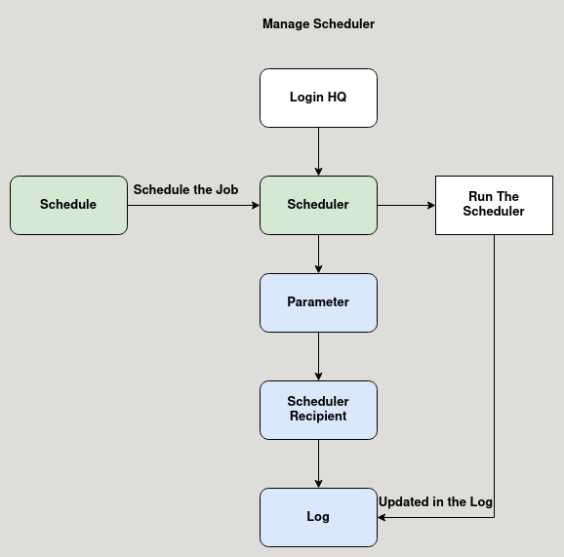

**Business Rules :**

* User shoul login as HQ/ Region.
* Some schedulers are not present in HQ/ Region.
* Example: Import Dms sale order scheduler is not present in HQ.
* Click test run to run the Database job, after the job completed it shows success message.
* A schedule is mapped to the scheduler master to run the job at specific time and day.
* Either the job is success or failure, user can check the details in the log tab.
* The scheduler recipient tab is used to map user to with email alert about the job status is sent.